ASSIGNMENT II

Consider the following schema:

Employee (EmpNo, EmpName, Sex, Salary, Address, DNo)

Department (DeptNo, DeptName, Location)

1. Create Employee table with following constraints:

* + Make EmpNo as Primary key
  + Do not allow EmpName, Sex, Salary and Address to have null values
  + Allow Sex to have one of the two values: ‘M’, ‘F’
  + Set the default salary value to Rs. 1000.

2. Create Department table with following:

Make DeptNo as Primary key

Make DeptName as candidate key

3. Insert few tuples into Employee and Department which satisfies the above constraints.

4.Modify / Delete a tuple which violates constraint and name the violated constraint.

5.Modify the foreign key constraint of Employee table such that whenever a department tuple is deleted, the employees belonging to that department will also be deleted.

6.a) Draw an ER Diagram for the following company database.

b) Convert ERD into relational schema

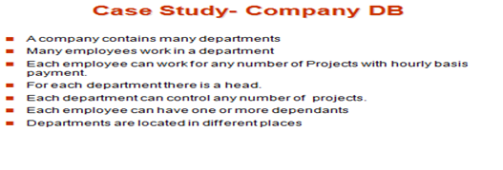

7. Draw an ER Diagram of online retail application which allows customers to purchase items from a rom a retail shop. Identify/Assume at least four entities and its attributes.

8. a)Draw an ER Diagram for the following College database.

b) Convert ERD into relational schema

